Patricia Stowell - First Light Flower Essences of New Zealand® Tutor and Registered Practitioner

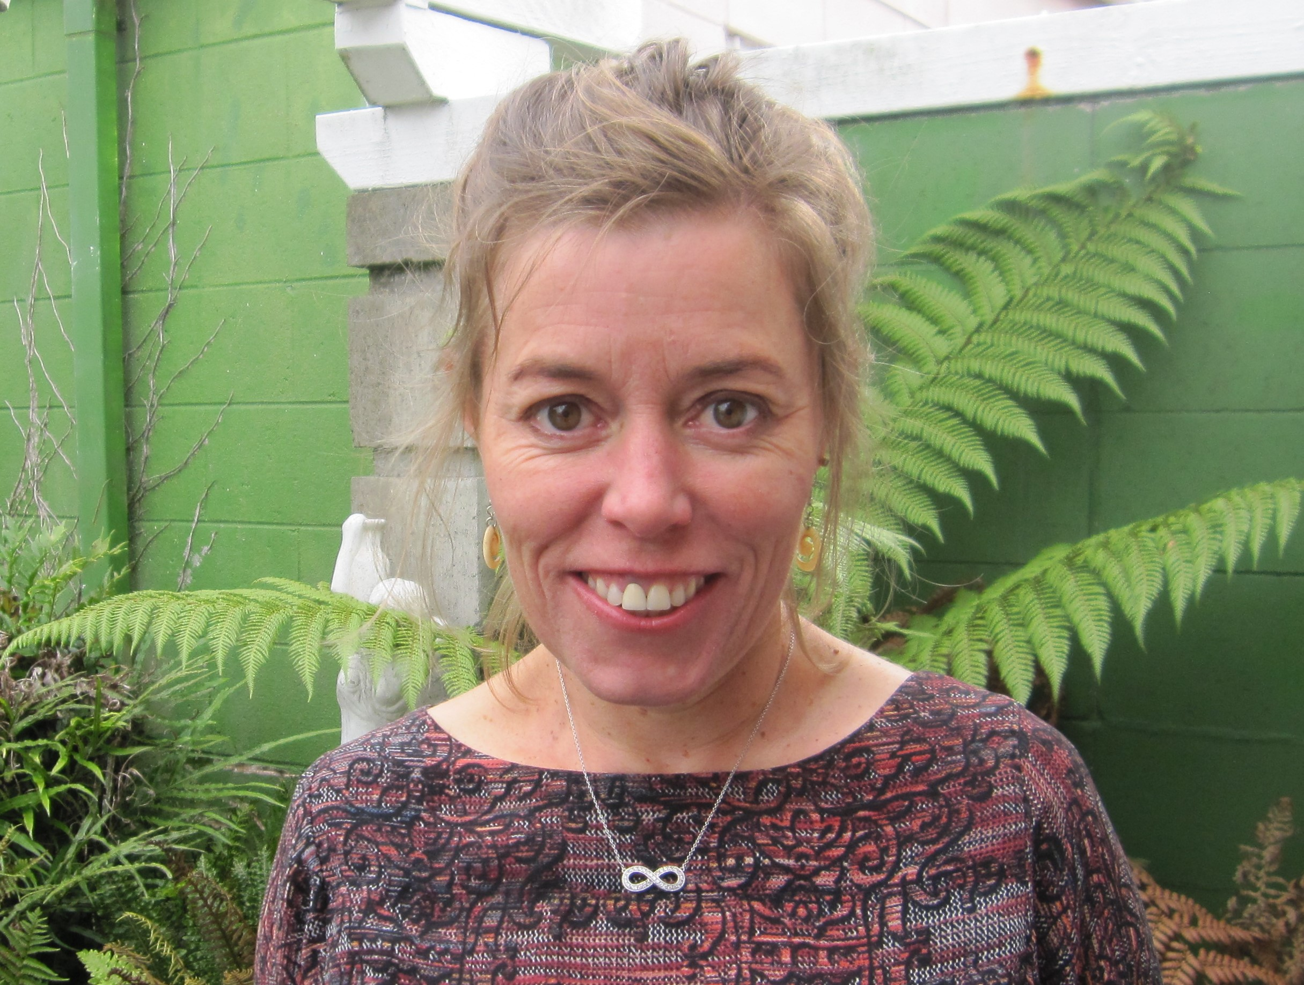
Patricia lives in Christchurch where she has her practice Soul to Sole. She practices Podiatry, flower essence therapy and is currently studying for her Diploma in Reflexology.

In 2010 Patricia discovered the First Light Flower Essences of New Zealand® and over the last 9 years she has obtained her Diploma in New Zealand Native Flower Essences, as well as several Medicine Woman Centre for Shamanic and Esoteric Studies® certificates.

Patricia is a First Light® Tutor currently facilitating workshops in Christchurch and Greymouth. She is passionate about supporting the needs of the soul/sole through the modalities of the Podiatry, Flower Essence Therapy and Reflexology.

______________________________________________________________

Gabrielle Euteneuer – International Universal Tao Instructor

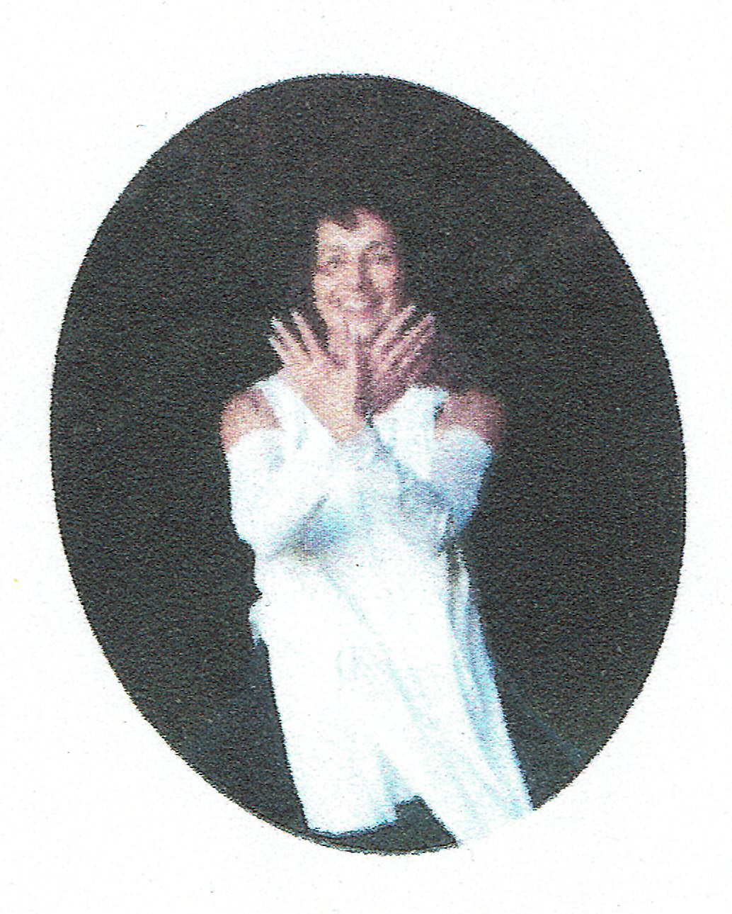
Gabrielle Euteneuer was born in Germany and now lives Oxford, Canterbury. To teach and live the daoist lifestyle, which she has done for more than 35 years is her life's vocation. For the last 25 years she has been traveling a lot in Europe, Thailand, USA, Australia and New Zealand, gaining more knowledge and then passing it on in teaching sessions.

Gabrielle is an International Healing Tao Senior Instructor and is authorized to train Associate Instructors. She works closely with the Founder of the Universal Healing Tao System, Master Mantak Chia. Gabrielle will be leading a mini workshop and introduction in Medical Qigong for practitioner self-care in the winter season.

