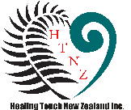

Healing Touch is a relaxing, nurturing energy therapy that uses gentle touch to assist in balancing physical, mental, emotional, and spiritual well-being. Healing Touch works with your energy field to support your natural ability to heal, is safe for all ages and works in harmony with and is complementary to standard medical care. International certification when all levels completed.

For more information

Call [NAME]

[Phone number]

[healingtouchnz.com](https://healingtouchnz.com)

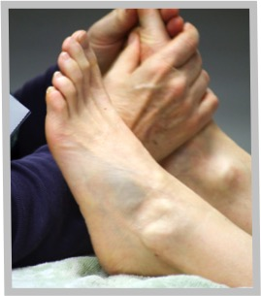



Healing Touch

Learn the foundations of successful energy work:

Partner work allows first hand experience feeling and interacting with the human energy field. Learn about self-care and healer preparation.

Gather a toolkit of techniques & know when & how to use them.

UNIT one Class

[time]

[day date month year]

[place]